**CAFE**

**Terra Coffee 4.8**

<https://www.terracoffee.com/>

912 N Yosemite St, Stockton, CA 95203

[(209) 645-2326](https://www.google.com/search?q=Terra+coffee+shop&oq=terra&aqs=chrome.0.69i59j69i57j46i433i512j0i433i512l2j69i60l3.2063j0j7&sourceid=chrome&ie=UTF-8#)

“Terra Coffee Roasters started as a Cottage Food Operation regulated by the California Homemade Food Act which allows certain foods, known as Cottage Foods, to be made in private homes and sold to the public. The Garcias source coffee beans around the world and micro-roast them at home weekly in six-pound batches, making every batch with the utmost care.”

https://www.downtownstockton.org/blog/from-love-coffee-stockton/

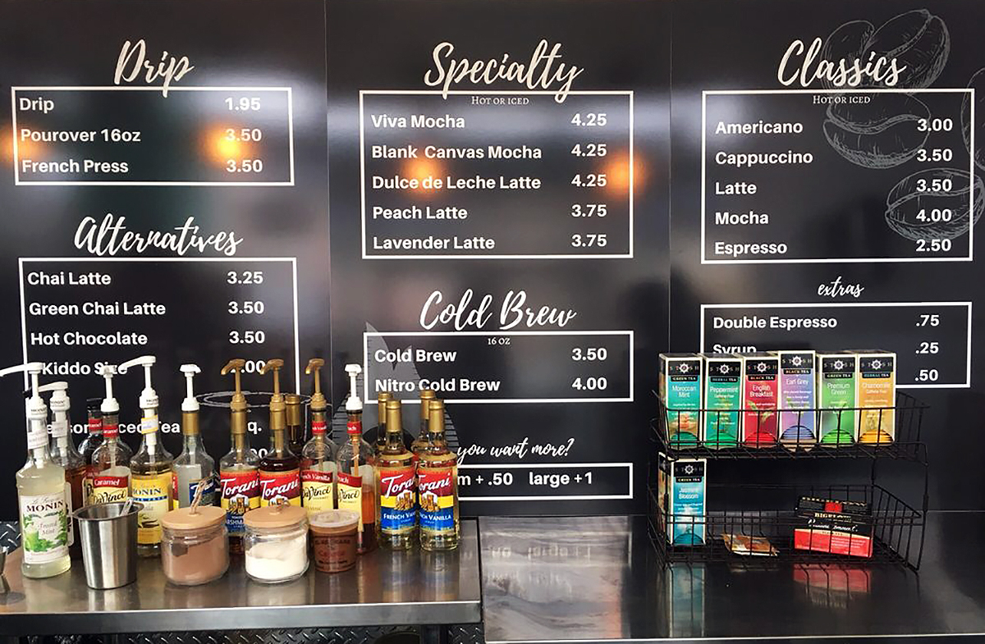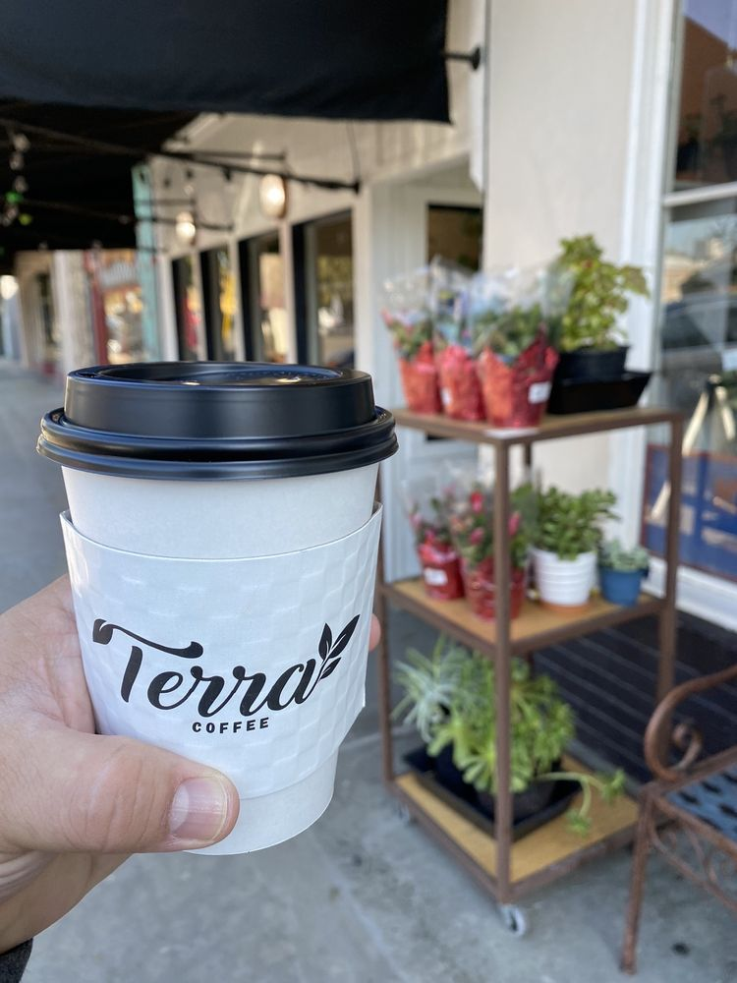

**Legendary Coffee and Books 4.8**

**445 W Weber Ave Suite 144A, Stockton, CA 95203**

[**(209) 395-3780**](https://www.google.com/search?q=legendary+coffee+and+books+stockton+menu&oq=legend&aqs=chrome.0.69i59l3j69i57j69i60l4.1963j0j9&sourceid=chrome&ie=UTF-8#)

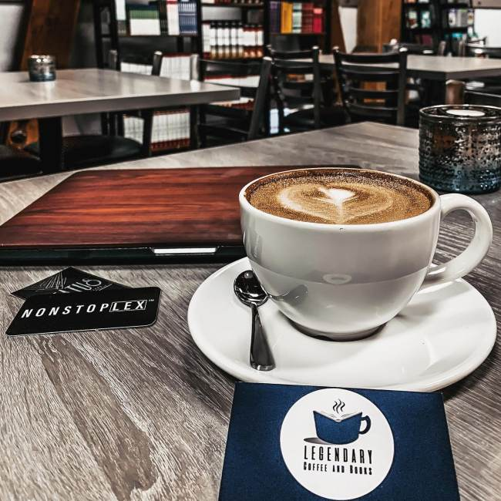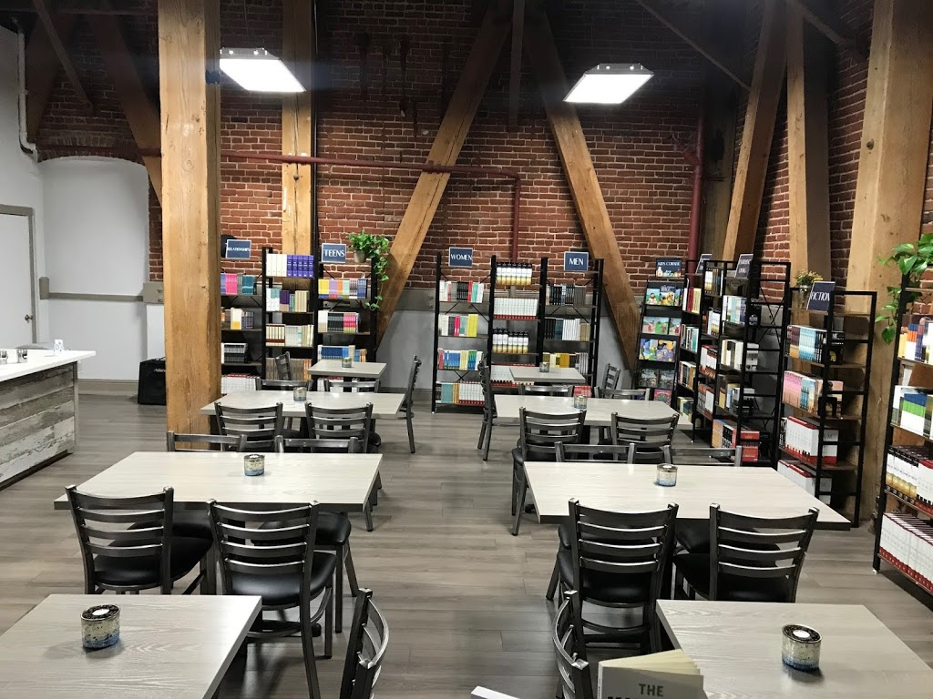

LCB is proud to partner with Temple Coffee out of Sacramento, CA. Their passion and innovative approach to coffee and its farmers are genuinely inspiring. Their roasting method is different for each coffee, making our customers drinking experience one to enjoy and remember.

**Empresso 4.6**

**1231 W March ln.**

**Stockton, Ca.**

**209-851-3903**

**Other Location**

**222 N. Eldorado St.**

**22 N. San Joaquin St.**

<https://www.empressocoffeehouse.com/>

**Locally owned and driven by community** - Empresso Coffeehouse started in the Miracle Mile neighborhood located within the lobby of the original Empire Theatre in Stockton, Ca. Since then we have spread throughout Stockton to three more locations allowing us to bring our passion for coffee to new areas in the city. Locally owned and operated by Troy and Rosann Burke, Empresso plans on continuing to grow and support more neighborhoods by creating spaces for our local communities to flourish.

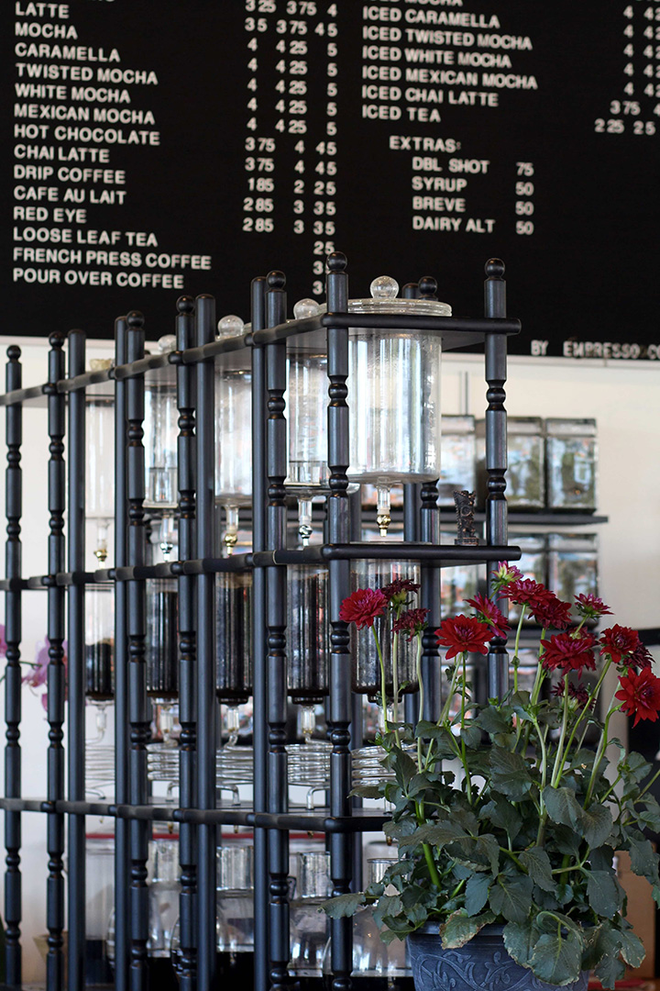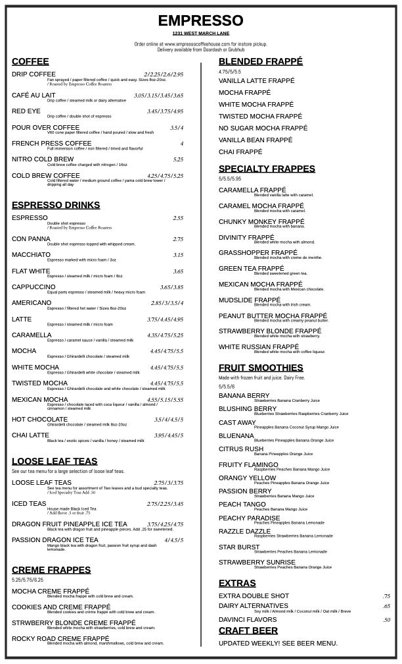

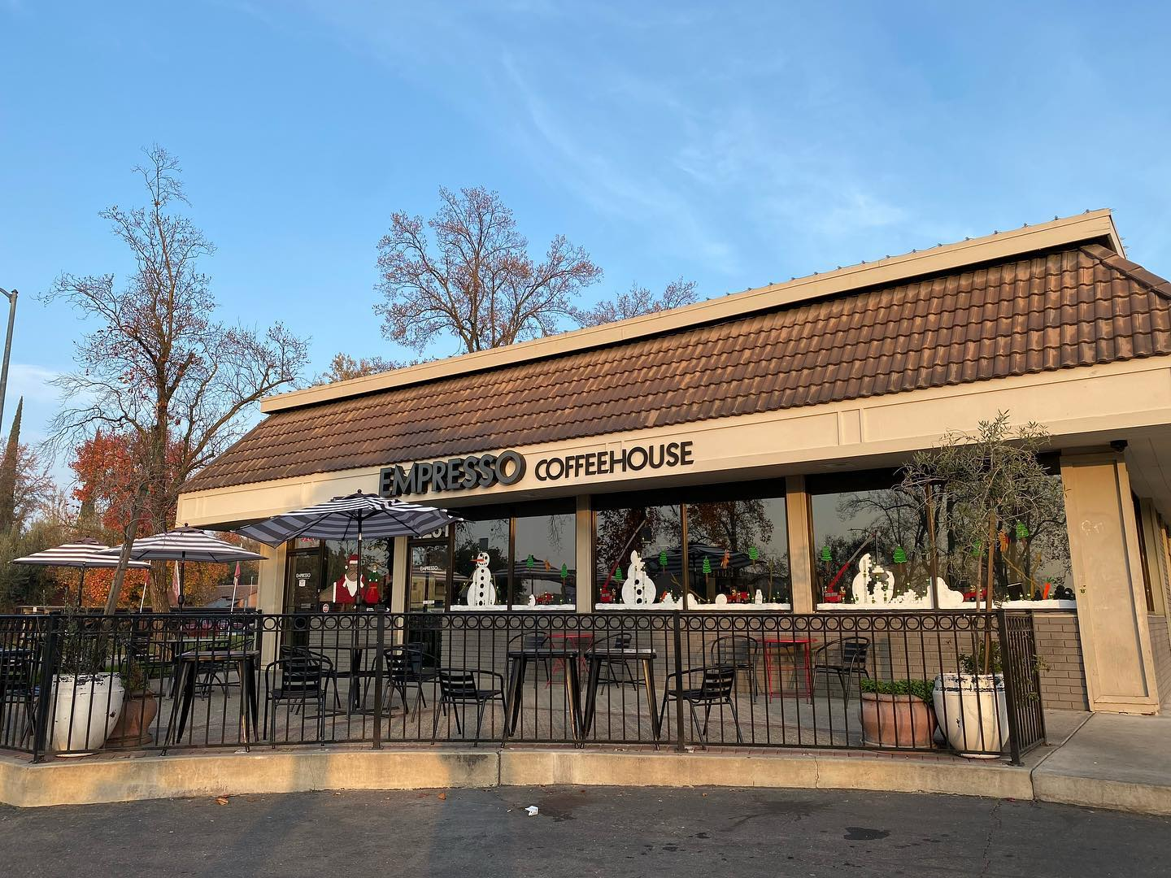

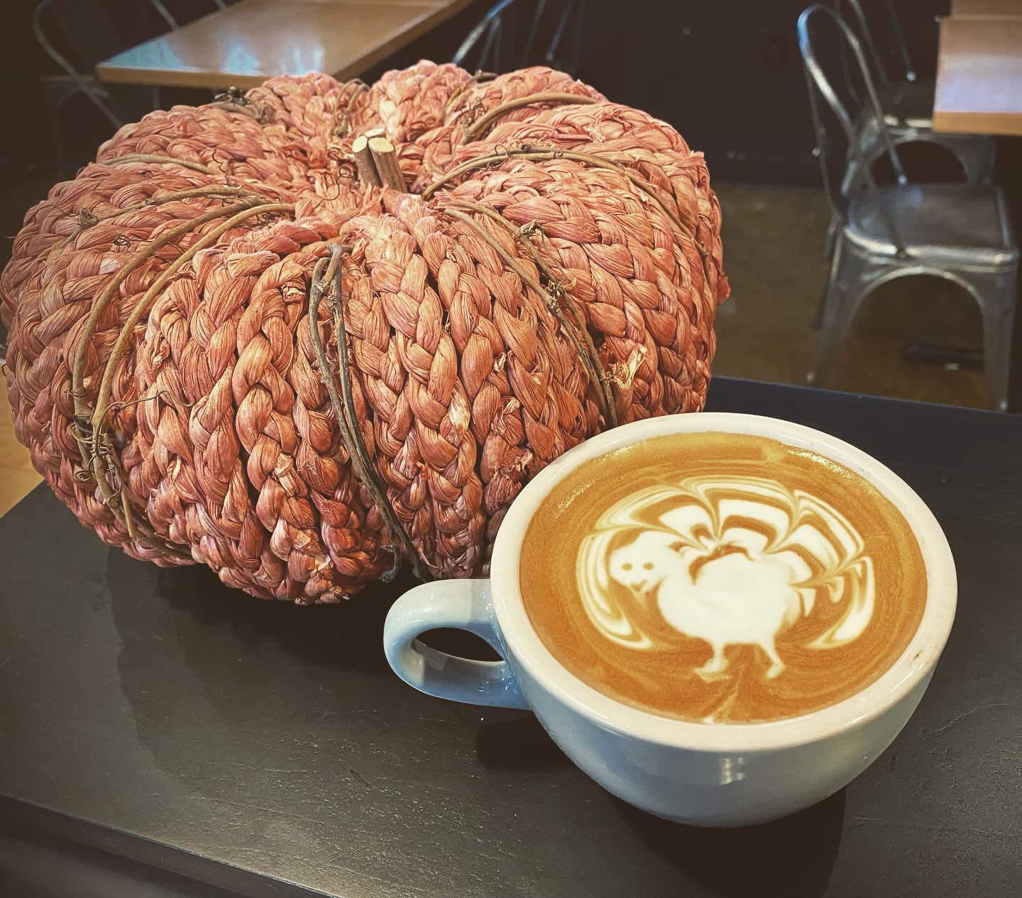

**Poppy’s Coffee 4.3**

<https://poppycoffee.business.site/>

4343 Pacific Ave

Ste. A-1

STOCKTON, CA 95207

United States

(209) 565-5737

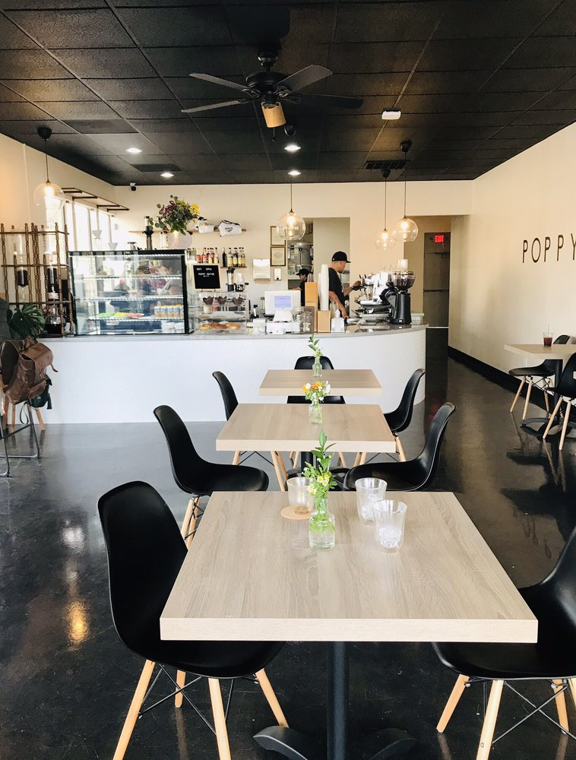

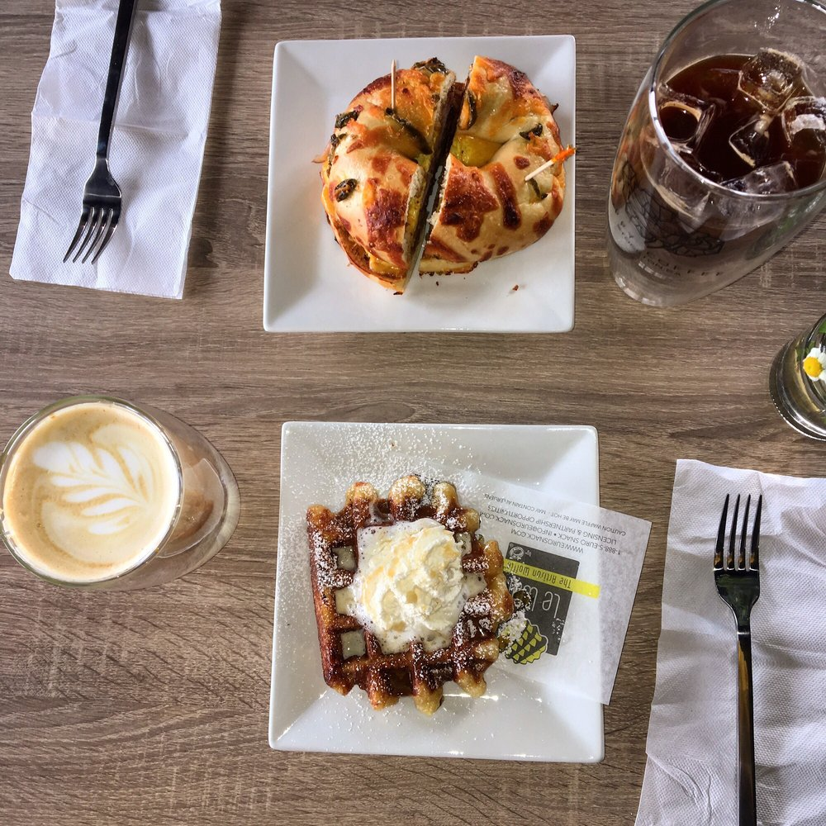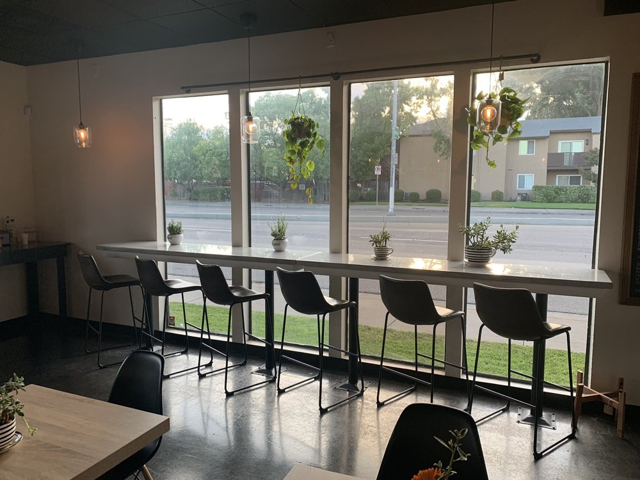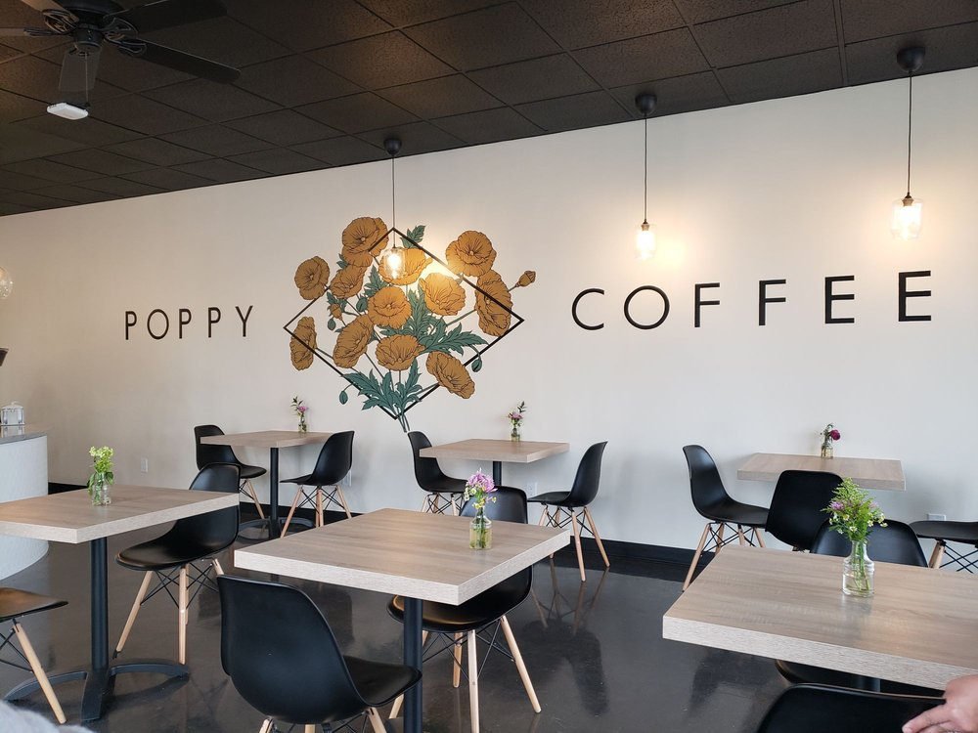

**Sweet Bot Cafe 4.6**

5634 N Pershing Ave Stockton, CA 95207

(209) 851-2734

https://www.sweetbotcafe.com/

Sweetbot Cafe in Stockton offers an array of creative desserts, froyo creations, boba drinks and so much more! Satisfy your sweet tooth and be sure to bring your camera to snap awesome Instagram-worthy photos with their vibrant neon branded sign and other trendy store decor.

